Cage name: MILLIONS  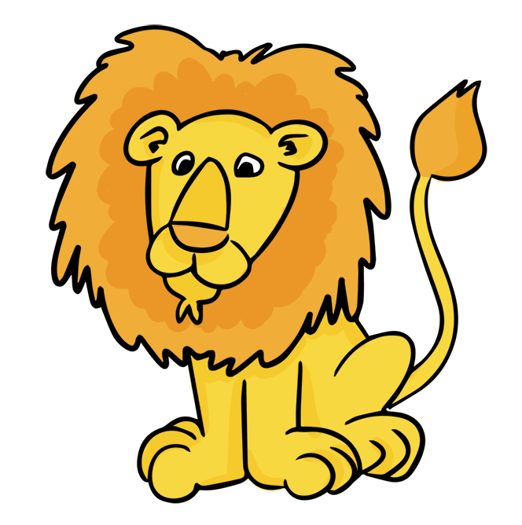 Hundreds Tens Ones | Cage name: THOUSANDS  Hundreds Tens Ones | ONES (No cage name)  Hundreds Tens Ones | . | Tenths Hundredths Thousandths
7 4 5 4 6 2 1 0 3 . 6 5 2

When naming numbers remember to say the number and then its cage name. For example: 745 462 103.652

We start by saying the numbers in the first cage.
Seven hundred forty five (Then the cage name) million
Then
Four hundred sixty two (Then the cage name) thousands
Then
One hundred three (This cage does not have a name)

Finally we have the decimal! The tricky but not so tricky part!
Here we say the number and then say the name of the last place value spot filled.

Six hundred fifty-two (last place value spot filled is) thousandths

745 462 103. 652
Seven hundred forty-five million four hundred sixty-two thousand one hundred three AND six hundred fifty-two thousands.
Notice that I used the word AND which stands for the decimal point.

Cage name: MILLIONS  Hundreds Tens Ones | Cage name: THOUSANDS  Hundreds Tens Ones | ONES (No cage name)  Hundreds Tens Ones | . | Tenths Hundredths Thousandths
7 4 5 4 6 2 1 0 3 . 6 5

When naming numbers remember to say the number and then its cage name. For example: 745 462 103.65

We start by saying the numbers in the first cage.
Seven hundred forty five (Then the cage name) million
Then
Four hundred sixty two (Then the cage name) thousands
Then
One hundred three (This cage does not have a name)

Finally we have the decimal! The tricky but not so tricky part!
Here we say the number and then say the name of the last place value spot filled.

Sixty-five (last place value spot filled is) hundredths

745 462 103. 65
Seven hundred forty-five million four hundred sixty-two thousand one hundred three AND sixty-five hundredths.
Notice that I used the word AND which stands for the decimal point.

Cage name: MILLIONS  Hundreds Tens Ones | Cage name: THOUSANDS  Hundreds Tens Ones | ONES (No cage name)  Hundreds Tens Ones | . | Tenths Hundredths Thousandths
7 4 5 4 6 2 1 0 3 . 6

When naming numbers remember to say the number and then its cage name. For example: 745 462 103.6

We start by saying the numbers in the first cage.
Seven hundred forty five (Then the cage name) million
Then
Four hundred sixty two (Then the cage name) thousands
Then
One hundred three (This cage does not have a name)

Finally we have the decimal! The tricky but not so tricky part!
Here we say the number and then say the name of the last place value spot filled.

Six (last place value spot filled is) tenths

745 462 103. 6
Seven hundred forty-five million four hundred sixty-two thousand one hundred three AND six tenths.
Notice that I used the word AND which stands for the decimal point.

Cage name: MILLIONS  Hundreds Tens Ones | Cage name: THOUSANDS  Hundreds Tens Ones | ONES (No cage name)  Hundreds Tens Ones | . | Tenths Hundredths Thousandths
7 4 5 4 6 2 1 0 3 . 6 0

When naming numbers remember to say the number and then its cage name. For example: 745 462 103.60

We start by saying the numbers in the first cage.
Seven hundred forty five (Then the cage name) million
Then
Four hundred sixty two (Then the cage name) thousands
Then
One hundred three (This cage does not have a name)

Finally we have the decimal! The tricky but not so tricky part!
Here we say the number and then say the name of the last place value spot filled.

Sixty (last place value spot filled is) hundredths

745 462 103. 60
Seven hundred forty-five million four hundred sixty-two thousand one hundred three AND sixty hundredths.
Notice that I used the word AND which stands for the decimal point.

Cage name: MILLIONS  Hundreds Tens Ones | Cage name: THOUSANDS  Hundreds Tens Ones | ONES (No cage name)  Hundreds Tens Ones | . | Tenths Hundredths Thousandths
7 4 5 4 6 2 1 0 3 . 6 0 0

When naming numbers remember to say the number and then its cage name. For example: 745 462 103.600

We start by saying the numbers in the first cage.
Seven hundred forty five (Then the cage name) million
Then
Four hundred sixty two (Then the cage name) thousands
Then
One hundred three (This cage does not have a name)

Finally we have the decimal! The tricky but not so tricky part!
Here we say the number and then say the name of the last place value spot filled.

Six hundred (last place value spot filled is) thousandths

745 462 103. 600
Seven hundred forty-five million four hundred sixty-two thousand one hundred three AND six hundred thousandths.
Notice that I used the word AND which stands for the decimal point.

