Extra Practice Questions for Measurement

Lesson 1: Measuring Length
Copy and complete. Use a ruler to help you.
1. a) 9 cm = ______ mm b) 40 cm = _____ mm

2. a) 70 mm = ____ cm b) 50 mm = _____ cm

3. a) 3000 mm _____ m b) 8000 mm = _____ m

4. a) 4 m = _____ mm b) 7 m = _____ mm

5. Which unit would you use to measure each item?
a) the length of a paperclip ___________________
b) the width of a book ___________________
c) the height of a tall tree ___________________
d) the thickness of a penny ___________________

6. Use >, <, or = Look at a ruler to help you if you need it!
a) 7 cm 70 mm b) 140 mm 11 cm
c) 80 mm 9 cm d) 24 mm 2.4 cm

Lesson 3: Exploring Rectangles with Equal Perimeters P = L + L + W + W

1. Write all possible rectangles with each perimeter. Make sure you draw the chart!
Example: 14 cm

A) 8 cm B) 18 cm

2. Write a rectangle with each perimeter and area.
Example: perimeter 24 cm and area 32 cm²

b) perimeter 22 cm and area 18 cm²

c) perimeter 22 cm and area 28 cm²

4. Justin has 48 m of fencing (perimeter) to put around his garden.
a) List all the possible lengths and widths of Justin’s garden.

b) Which dimensions will Justin choose if he wants the garden with the greatest possible area? The least possible area?
Greatest: Least:

5.a)Draw a rectangle 12 cm long and 8 cm wide.
USE YOUR RULER!!!
Remember to also write the units.
b) What is the perimeter of the rectangle?

c) What is the area of the rectangle?

Lesson 4: Exploring Rectangles with Equal Areas A = L x W

1. Write the dimensions of each rectangles with each area and perimeter.
a) area 24 cm² and perimeter 28 cm

b) area 16 cm² and perimeter 16 cm

2. Draw all the possible rectangles with each area.
Example) 12 cm²

a) 36 cm²

6. Amelia and Olivia made a rectangular garden with an area of 24 m².
Example) Find the dimensions of all the possible rectangles and record the perimeter of each garden they can make.

7. Jasper and Kyle want to make a rectangular garden with an area of 60 m².
Example) Find the dimensions of all the possible rectangles and record the perimeter of each garden they can make.

Lesson 6: Measuring Volume in Cubic Centimetres V= L x W x H

1. Find the volume of each rectangular prism.

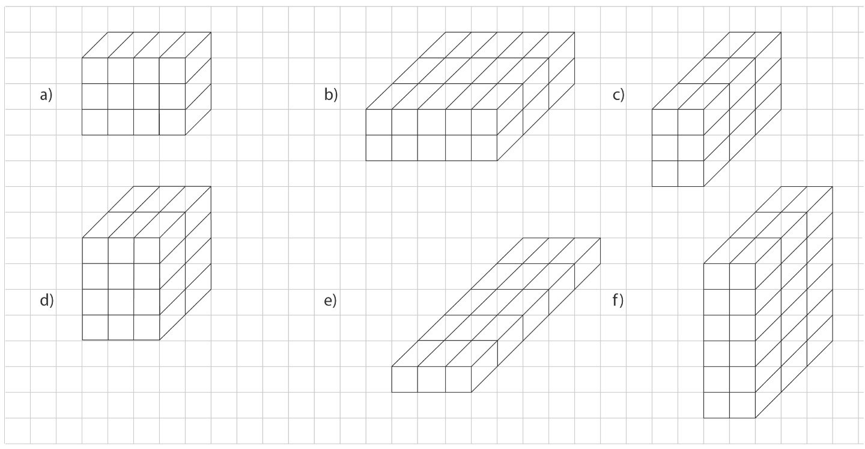
A) B) C)
D) E) F)
2. Lane and Jaxon have a box with a volume of 16 cm³ . The box is 4 cm tall.
a) How long and how wide might Lane and Jaxon’s box be?
Give as many answers as possible.

Lesson 7: Constructing Rectangular Prisms with a Given Volume
1. Build a rectangular prism with each set of dimensions shown in the table. Find the volume of each prism.

Length (cm) | Width (cm) | Height (cm) | Volume (cm³)
3 | 4 | 2
8 | 2 | 1
4 | 5 | 2
6 | 3 | 2

2. Write all the possible rectangular prism dimensions with a volume of 18 cm³ .

3. Suppose Anthony and Matthew wanted to build a rectangular prism with 35 centimetre cubes.
They put 7 cubes in the bottom layer.

a) How many layers of cubes will Anthony and Matthew need?

b) What are the dimensions of the prism?

Lesson 9: Exploring Capacity: The Litre
1. Choose the better estimate.
a) a jug of orange juice 4 L or 40 L
b) a wading pool 2 L or 200 L
c) a pail 10 L or 100 L
d) a bottle of ketchup 1 L or 10 L

Lesson 10: Exploring Capacity: The Millilitre

1. Choose the better estimate.
a) an eyedropper 1 mL or 200 mL
b) a teacup 25 mL or 250 mL
c) a bottle of shampoo 75 mL or 750 mL
d) a water bottle for a gerbil 6 mL or 250 mL

2. Would you use millilitres or litres to measure each container? Circle the answer.
a) a teaspoon mL or L
b) a drinking glass mL or L
c) a vinegar jug mL or L
d) an aquarium mL or L
e) a soup bowl mL or L
f) a drink box mL or L

3. Order from least to greatest capacity.

a) 2 L, 1000 mL, 40 mL, 750 mL

b) 76 mL, 14 mL, 5 L, 17 mL, 17 L

4. Copy and complete.

a) 3 L = _____ mL b) 7 L = _____ mL c) 10 L = _____ mL

d) 2000 mL = _____ L e) 9000 mL = _____ L f) 1000 mL = _____ L

5. Abby drank 375 mL of water from her 1-L bottle.
How much water is left in Abby’s bottle?

6. Natalie and Grace are making juice. They poured 680 mL of juice into a 1-L jug.
How many more millilitres will their jug hold?

Lesson 11: Relating Capacity and Volume
Makayla has a graduated cylinder that holds 1 litre. She would like to measure the volume of 10 marbles. The left cylinder shows the amount of water in the cylinder before she added the marbles while the right shows the amount after she added the marbles. What is the volume of 10 marbles, 5 marbles, and 1 marble?

10 marbles:
5 marbles:
1 marble:

