Cage name: MILLIONS  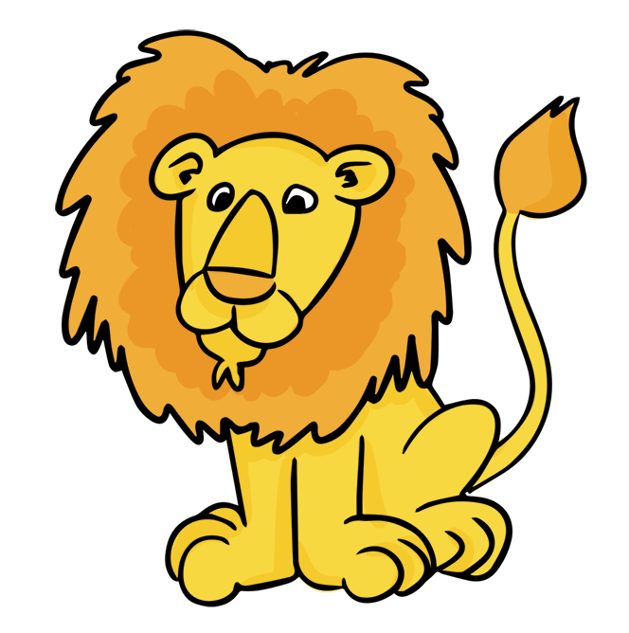  Hundreds Tens Ones | Cage name: THOUSANDS  Hundreds Tens Ones | ONES (No cage name)  Hundreds Tens Ones

7 4 5 4 6 2 1 0 3

When naming numbers remember to say the number and then its cage name. For example: 745 462 103

We start by saying the numbers in the first cage.
Seven hundred forty five (Then the cage name) million
Then
Four hundred sixty two (Then the cage name) thousands
Finally
One hundred three (This cage does not have a name)

745 462 103
Seven hundred forty-five million four hundred sixty-two thousand one hundred three

Notice that I did not use the word AND when naming my number, we will learn about this more later, but AND stands for a decimal point.

